Military Institute of Science and Technology

Department of Computer Science and Engineering

Course Title: Data and Tele-Communication Sessional

Course Code: CSE-318, Cr. Hr: 1.50

Level-3, Term-2

Experiment No: 15

**Name of the Experiment: Study of Line Coding NRZ Non-Return-to-Zero**

Since the wave forms have a peak value of 5v, both data 1 levels would slip downwards by 2.14v. This would result in final voltage levels of data 0 = -2.14v and data 1 = +2.86v.

As the peak voltage of the received signal decreases it may well slip below the level recognized by the receiver as a level 1 and thus data could be misread. In the extreme case where the input happened to be a constant series of logic 1s then the NRZ(L) out put would be a constant level. Now if the input changed to a stream of logic o’s NRZ s- the output would still be a constant level. The only difference would be the DC level. At the receiver, if all the DC levels had been lost, we would had no way of knowing whether the original input was all o”s or all 1”s.

**Receiver clock**

If the receiver has to derive its own clock and has to keep it in step with the transmitter clock, it must use the changes of data to provide some timing information. A data stream consisting of only o’s or only 1’s will leave the receiver without these timing clues and will make the clock design slightly more complex.

**Bandwidth**

Imaging we wanted to send one complete, 1’0 cycle of data. We would need one complete clock pulse to send the logic 0. Therefore two complete clock cycles are needed to send one cycle of data. So, the maximum rate of data transfer is half he rate of the clock pulse. You will also see, as we look as the other forms of conditioning that the NRZ(L) method requires only a comparatively narrow band width.

The simplicity of the data wave form and the relatively narrow band width, dispite the drawbacks mentioned, make it a popular choice in many communication systems.

Now we will investigate practically.

**Practical Notes**

Before carrying out any of the following practical exercises, ensure that all of the electrical equipment involved is initially switched off.

* A solid block indicates actions to be carried out. Record the results of your experiments in your workbook.

You should switch your scope Y amplifier inputs to DC and connect the scope ground to 0V.

**Practical Exercise -A Look at the NRZ (L) Code**

This Practical Exercise uses boards MODICOM 3/1 and MODICOM5/1.

* Set up the MODICOM 3/1 boards as follows:

Mode switch set to fast

Sync code generator switch to off

Error check code selector switches to A = 0 B = 0

Switch faults –all switched off

* On the MODICOM 5/1 board check that the mode switch is set to position 1.
* Connect the +5 volt, +12 volt and the -12 volt supplies to the boards and link their zero volt connections as shown in figure 17 oppossite.
* Make the following two connections:

MODICOM 3/1 Tx clock output tp3 to MODICOM 5/1 Tx clock input

MODICOM 3/1 Tx data output tp44 to MODICOM 5/1 Tx data input

* On MODICOM 3/1 connect the DC1 output on the function generator block to the channel 0 (CH.0) input tp 10 and then connect a wire from this point to channel 1 (CH.1) input tp 12.

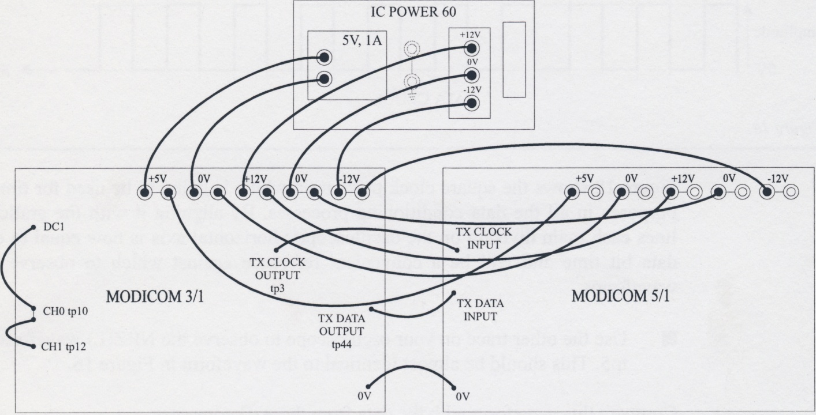

* Switch on the power supply.

We are now able to supplu the same DC voltage level to each of the channels.

Remember that the two channels are going to be multiplexed together by TDM.

* Adjust the DC 1 preset until the A/D Converter LEDs show the value:

D6 D5 D4 D3 D2 D1 D0

0 1 0 0 0 1 1

* Connect the oscilloscope`s external trigger input to MODICOM 3/1`s Tx to output signal at tp4 and switch the oscilloscope to external, negative edge triggering.
* Use your oscilloscope to observe the Data Clock output at tp4 in MODICOM 5/1 `s Data Conditioning block up in the top left of the board .
* Adjust the oscilloscope`s timebase and X-position controls until each rising edge of the data clock coincides with one of the oscilloscope `s vertical graticule lines as shown. It will probably be necessary to adjust the oscilloscope`s trigger. Level manually to obtain a stable trace.

Figure 18 shows the square clock pulse train which is going to be used for timing purpose in all the data conditioning processes . By aligning it with the graticule lines each main division on the oscilloscope `s horizontal axis is now equal to one data bit time and will be a convenient reference against which to observe the waveforms.

* Use the other trace on your oscilloscope to observe the NRZ(L) waveform at tp5. This should be almost identical to the waveform in figure 16.

Compare this waveform with the data from the A/D converter:

D6 D5 D4 D3 D2 D1 D0

0 1 0 0 0 1 1

You will see that the least significant bit D0 is transmitted first and then through to D6 on the right hand end of the oscilloscope trace .

You will have noticed that there is a logic 0 being transmitted ahead of the first bit so from left to right on the oscilloscope screen, the logic levels read :0 , then 1100010.

2.6a The data 0 being transmitted ahead of the first bit is:

1. Reserved for the output from the Sync Code Generator which ,at the moment , is switched off.
2. An odd parity bit
3. A transmission delay
4. A zero voltage level indicator

You may recall from your work on MODICOM 3 that we have two input channels , channel 0 and channel 1, that are combined by time division multiplexing (TDM). The two channels are sent in a group of 15 bits or timeslots. The Sync bit comes first, followed by the 7 bits of channel 0 and finally the 7 bits of Channel 1 . The whole group of fifteen timeslots is called a ‘Timing frame’.

* In your workbook, draw (in pencil ) the clock pulses and the whole waveform that you would expect for a complete timing frame when the above data is being transmitted over both channels. (If you have difficulty with this , return to your notes on the MODICOM 3 for some revision)

Now we can observe this on the oscilloscope .

* Adjust the oscilloscope `s timebase and X- position controls until you have exactly two clock pulses within each of the oscilloscope `s vertical graticule lines .
* Monitor the NRZ(L) waveform at tp5 once again.

You should now be able the see the complete timing frame:

* Check the waveform in your workbook making any corrections necessary.

Investigate carefully to find the cause of any errors and make a note to remind yourself .

Having two channels available , it would be more usual to make full use of them by sending different information on each of them.

* Switch off the power supply.
* Keep the oscilloscope set up to monitor the whole timing frame and make the following changes. Remove the lead at the input to CH. 1 which goes from tp10 to tp12. Now connect the C H.1 input tp12 to the DC2 supply.
* Switch onthe power supply.
* Observe the effect on the timing frame as you adjust the DC1 and DC2 preset controls.